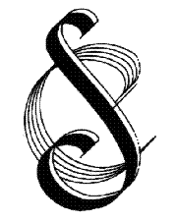 | Streatham Choral Society  Founded 1921  Registered Charity No. 802195
COOKIE POLICY
Key details
Effective date | January 2021
Date of last review | February 2023
Reviewed by | Martin Gresty (Secretary)
Approved by Committee | March 2023
Next review date | February 2024

Cookies on Streatham Choral Society’s website
Streatham Choral Society’s website pages use small text files called a 'cookie', which is downloaded onto visitors’ computers. This is called a session cookie. This will only remain on a visitor’s computer until you close your browser. This cookie is not used to identify a viewer personally in any way.
This type of cookie is used to collect aggregated website statistics that allow the Society to understand how visitors use the site.

All information collected will be anonymous and only used to help improve the website and report to funders on usage. A persistent cookie will be downloaded when a visitor first visits the site. These remain in the browser’s cookie store between sessions. This type of cookie will allow identification of repeat visitors to the site. Persistent cookies are also used to allow registered users to use the site without logging in on every visit. Visitors may opt to view the site without cookies by adjusting their browser's settings.

Disabling cookies
You can typically remove or reject cookies via your browser settings. In order to do this, follow the instructions provided by your browser (usually located within the “settings”, “help” “tools” or “edit” facility). Many browsers are set to accept cookies until you change your settings.

If viewers do disable cookies some functions of the site may no longer work correctly. For more information on cookies see the All About Cookies website (www.allaboutcookies.org.uk).

