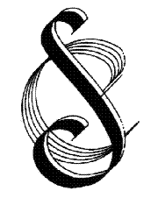 | Streatham Choral Society  Founded 1921  Registered Charity No. 802195

COMPLAINTS PROCEDURE
Key details
Effective date | September 2016
Date of last review | February 2023
Reviewed by | Martin Gresty (Secretary)
Approved by Committee | March 2023
Next review date | February 2024

In the first instance, internal complaints can be made to the elected section representatives to pass on to Committee members as appropriate. Members of the Society can also make complaints directly to any Committee member to be then acted upon. Unless a complaint is received during the summer recess, complaints would normally be resolved within a month.
Formal complaints from members or from external bodies should be sent to the Secretary StreathamChoral@gmail.com and these will be brought and considered at the next Committee meeting for discussion. The Committee meets at least once per term so outcomes of a formal complaint could take a maximum of four months to resolve.

